Supplementary Data 1. School cafeteria worker health screening questionnaire

* The questionnaire below is a questionnaire for health assessment of fumes generated in the cooking process during current work, and the information collected will be used as a basis for health assessment and promotion.

School cafeteria worker health screening questionnaire
Name |  | Reception Number |  | Current workplace
- Sex
- Male □ Female
- Date of birth ( )Year ( )Month ( )Day
- Height ( )cm Weight ( )kg

* Occupational history
- What are your main job responsibilities??
- cooks □ kitchen assiastants (Preparation job)
□ Nutrition teachers(Clerical work) □ Others( )
- How long you've been working at your current job
( Year Month)
- How long you've been in the job
( Year Month)
< If you checked Cooks and Assistant Cooks, please answer question 7, otherwise please answer from question 16.>
- Please list the number of hours you work per day.
Start time:
End time:
- How much cooking do you do in a workday?
□ Most of the time □ More than half □ Less than half □ Others
- Current work arrangement
- Day □ Shift work (two shifts) □ Shift work (Three shifts) □ Others ( )
- What are the main recipes of cooking?
- grilling □ Boiling □ stir-frying □ frying □ Others ( )
- How many meals per week do you perfume recipes that use heat, such as frying, stir-frying and grilling
- At every meal □ More than half □ Less than half □ Others ( )
- What are the main ingredients you use in cooking?
□Vegetables □ Meat □ Fish □ Others
- What is the main heat source for cooking
- Gas □ LPG □ Oil □ Briquettes □ Others (Electric plates, Electric appliance)
- What about ventilation during cooking in workplace
- Open window only □ Open windows and turn on fans
- Turn on the fan only □ No special ventilation
- Is there a hood installed in your kitchen? Please check the box where it is installed.
- On top of rice cooker
- Above the dishwasher
- Above the pot
- On the countertops
15-1. Check the box for the type of hood you have installed.
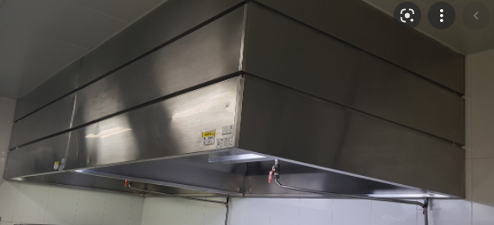 | 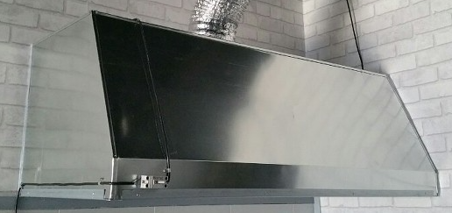
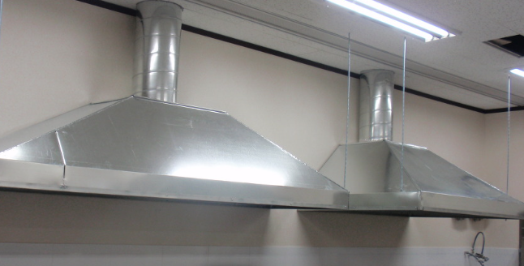 | 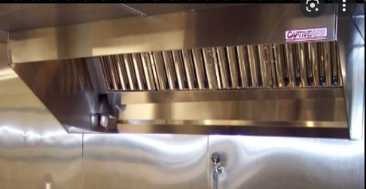
- Do you wear a mask while cooking?
□ No(☞ Go to question 19.) □ Yes(☞ Go to questions 16-1.)
16-1. Did you wear a mask while cooking before the pandemic?
□ No □ Yes

* Health history (past medical history)
- Have you been diagnosed with, or are you currently taking medication for, any of the following conditions? □ Not applicable
 | Tuberculosis | Asthma | Chronic obstructive lung disease | Allergic rhinitis | Atopic dermatitis | Allergic keratitis/  Conjunctivitis | Dry eye syndrome | Cancer | Hepatitis | Others
Diagnosis | □ | □ | □ | □ | □ | □ | □ | □ | □ | □
Medication | □ | □ | □ | □ | □ | □ | □ | □ | □ | □

* Smoking history
- Have you ever smoked more than 5 packs(100 cigarettes) of cigarettes in your lifetime?
□ No(☞ Go to question 19.) □ Yese(☞ Go to question 18-1.)
18-1. Do you currently smoke cigarettes?
□ Currently smoke | smoked | ( )years
□ Currently smoke | Average | ( )cigarettes per day
□ Smoked in the past but not currently smoke | Smoking Period | ( )years
□ Smoked in the past but not currently smoke | Average | ( ) cigarettes per day
□ Smoked in the past but not currently smoke | Quit smoking | ( )years
- Have you ever smoked electronic cigarettes(heated tobacco, eg., icos, glory, etc.)?
□ No(☞ go to question 20.) □ 예(☞ go to question 19-1.)
19-1.Do you currently smoke electronic cigarettes(heated tobacco)?
□ Currently smoke | smoked | ( )years
□ Currently smoke | Average | ( )cigarettes per day
□ Smoked in the past but not currently smoke | Smoking Period | ( )years
□ Smoked in the past but not currently smoke | Average | ( ) cigarettes per day
□ Smoked in the past but not currently smoke | Quit smoking | ( )years
- Have you ever used vaporizers?
□ No(☞ go to question 21.) □ Yes(☞ go to question 20-1.)
20-1. Have you used vaporizers in the past month?
□ No □ 1~2 day/month □ 3~9 day / month □ 10~29 day / month □ Daily
- Are you frequently exposed to secondhand smoke?
□ No □ Yes

* Questions about cooking at home
- On average, How many time do you spend cooking at home every day?
- Less than 30 minutes □ 30 minutes ~ 1 hour □ 1 hour~2 hour
□ 2 hour~ 3hour □ More than 3 hours
- What type of heat source do you use for cooking at home?
- Gas □ LPG □ Oil □ Briquettes □ Others (Electric plates, Electric appliance)
- What about ventilation during cooking at home?
- Open window only □ Open windows and turn on fans
- Turn on the fan only □ No special ventilation

