Supplementary Fig. 3. The plot of the total number of allergic rhinitis per 1,000 capita along the time. Blackline: predicted cases on the scenario, which introduced a CHP in January 2015. Redline: counterfactual scenario with no CHP. (A) Model based on 6 case dongs. (B) Model based on 6 control dongs. (C) Model based on 5 case dongs, except Pungsan-dong.
CHP: combined heat and power.
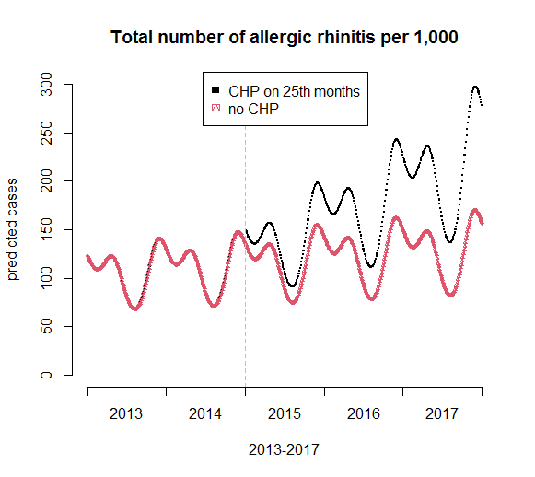 Model based on 6 case dongs | 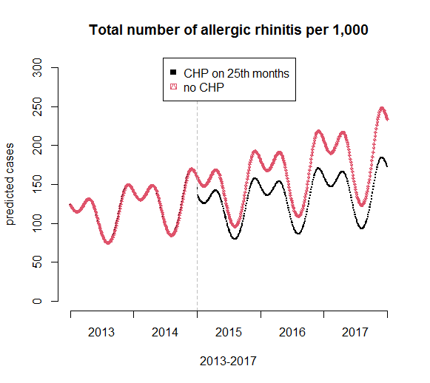 Model based on 6 control dongs
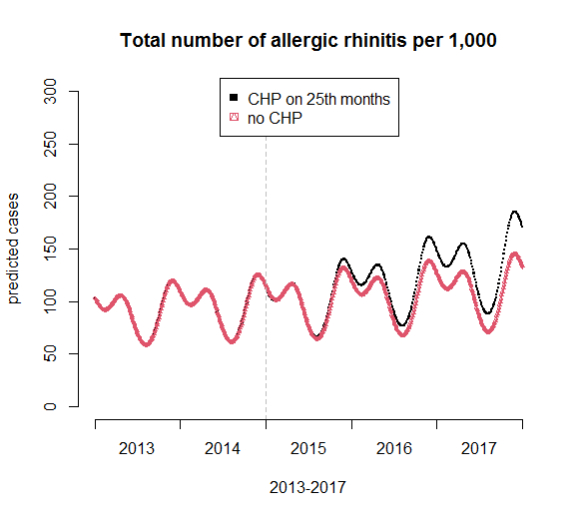 Model based on 5 case dongs, except Pungsan-dong

