**Figure S1**. Nonlinear association between weekly working hours, risk for CHD, and risk for stroke, stratified by age (<45y)

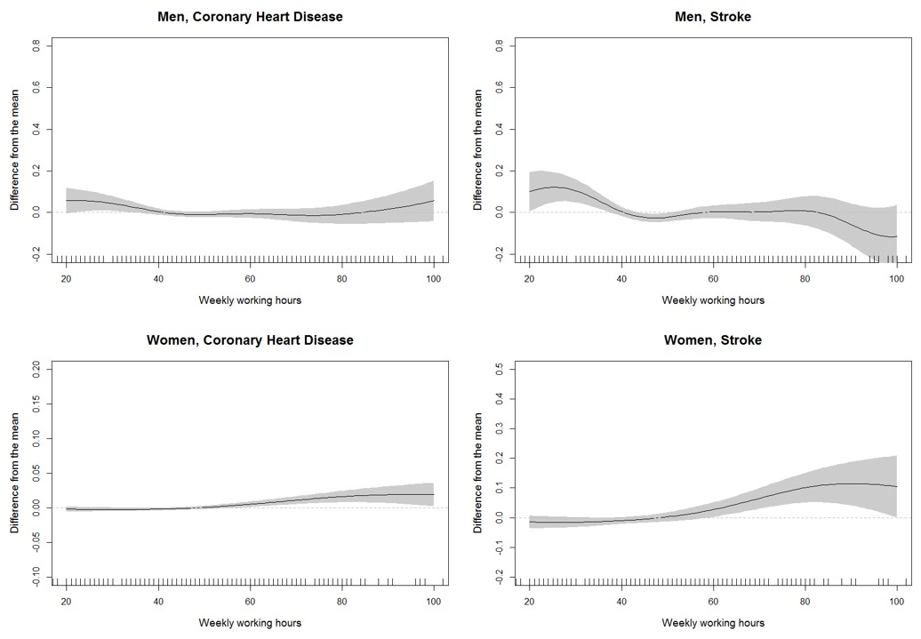

Nonparametric associations of weekly working hours with calculated 10-year risks for CHD and stroke. Data were adjusted for household income, employment condition, occupation, and shift work.

**Figure S2.** Nonlinear association between weekly working hours, risk for CHD, and risk for stroke, stratified by age (≥45y)

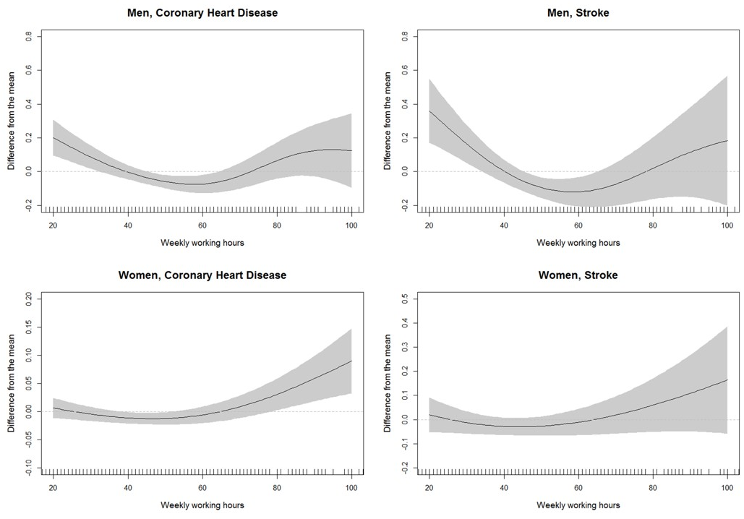

Nonparametric associations of weekly working hours with calculated 10-year risks for CHD and stroke. Data were adjusted for household income, employment condition, occupation, and shift work.